SSL VPN Installation

1. Start Chrome Enter the below Public IP Address.

[**https://103.224.241.233:4422/**](https://125.99.78.222:8443/)

2. Login to Sophos user portal using Windows Credential.

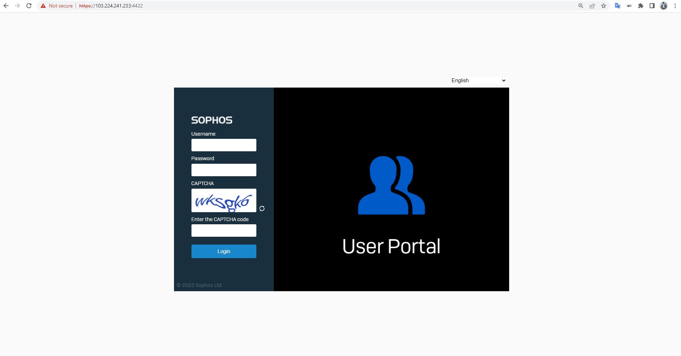

3. Download and install “Google Authenticator” from the Play store on your phone.if you have already installed please ignore this step.

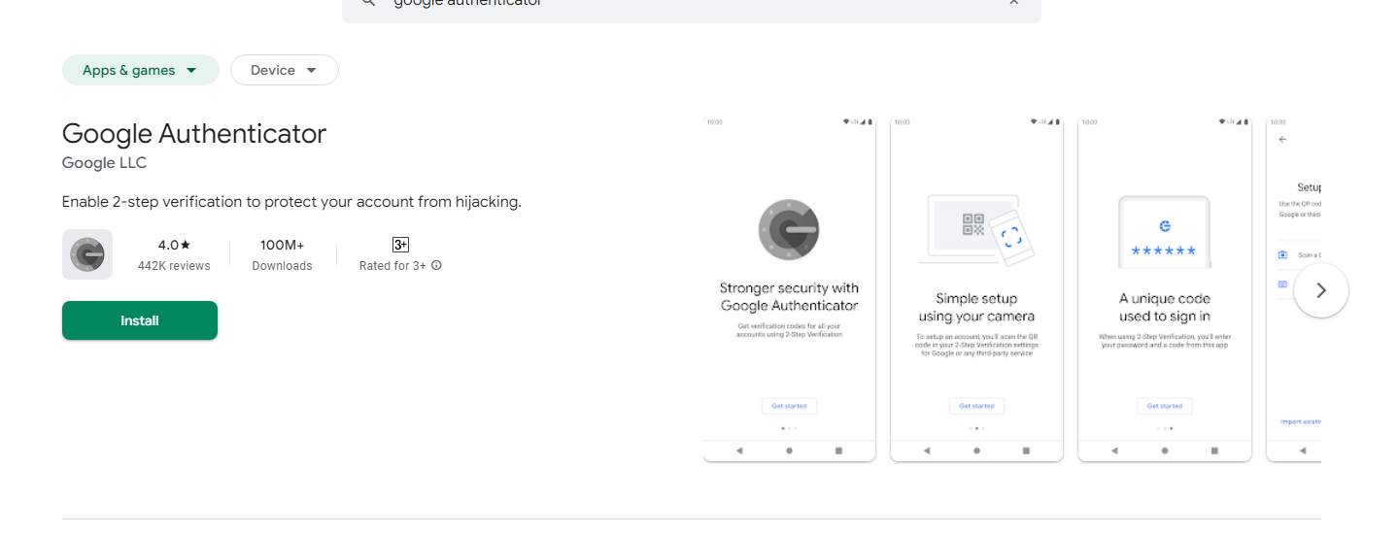

4. Open “Google Authenticator” and click on “Scan QR code” and scan.

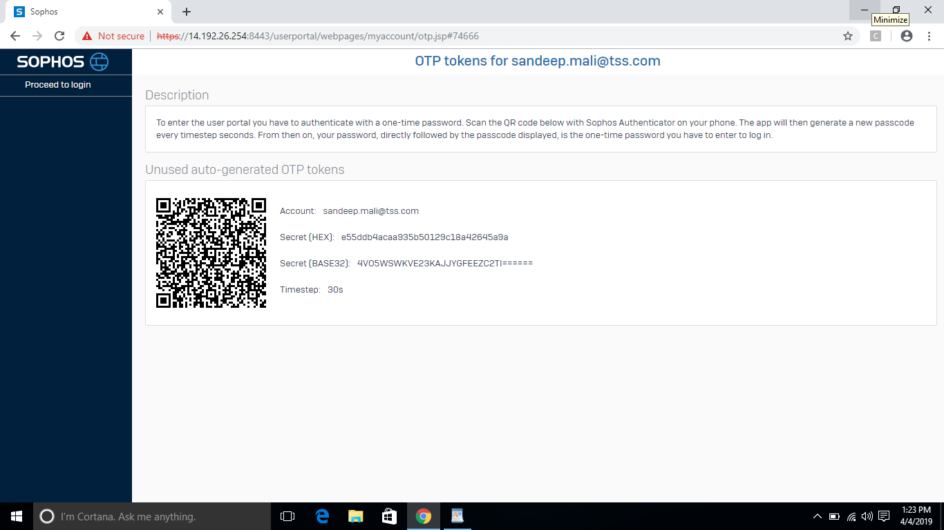

5. Click on “Proceed to Login”

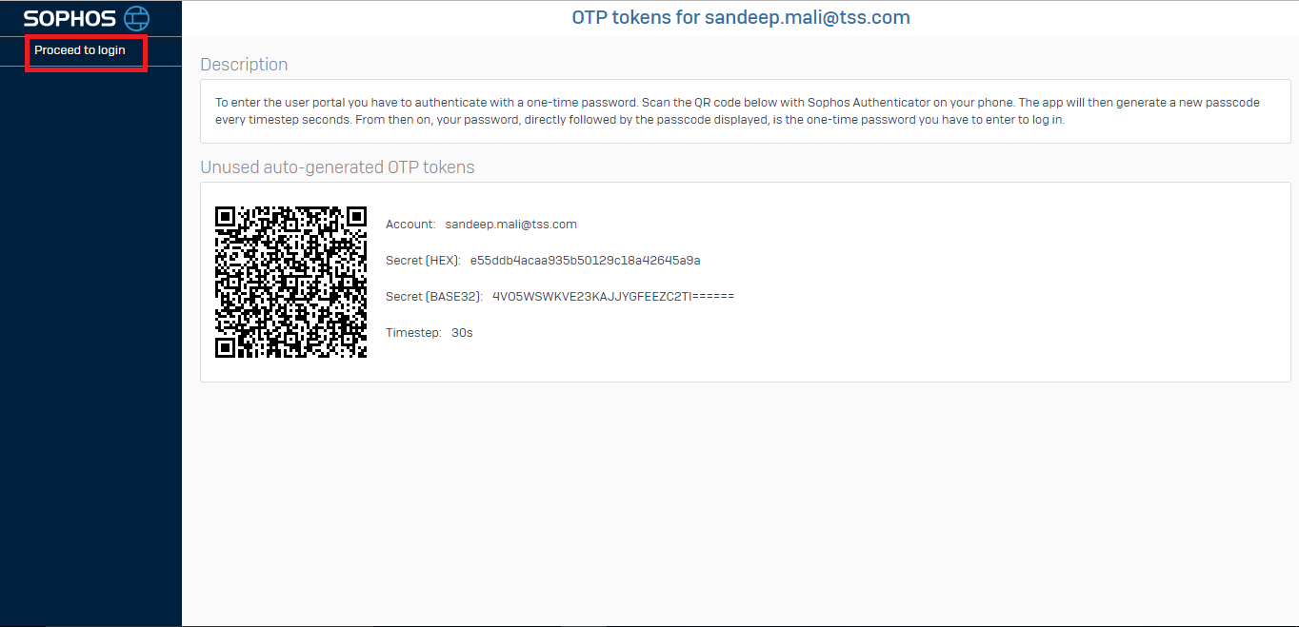

6. Login using your windows credential but add the authentication code after the password.

**Eg: If you user name is “ABC” and the password is “Temp@123” and the authentication code in application is “******” then you will be login in like this.**

**User Name: ABC**

**Password: Temp@123\*\*\*\*\*\***

7. Click on “SSL VPN”, then on the right side page click on “Download for windows and configuration for Windows” .

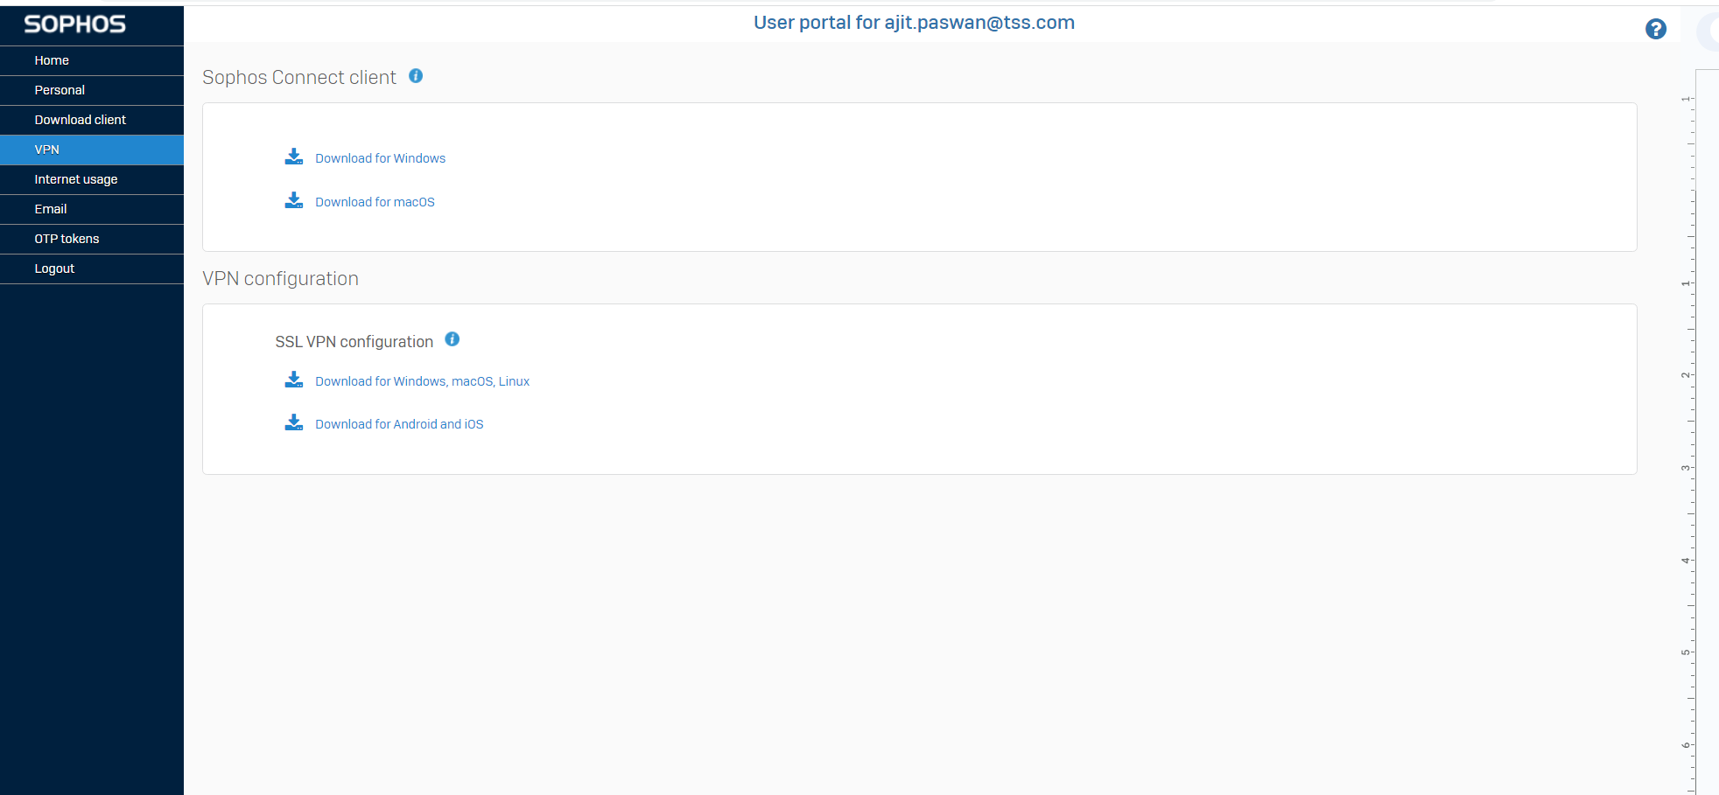

8. After downloading the “Sophosconnect” exe file then run with admin credentials to install on your laptop/desktop.please contact IT Admin team for admin credential.



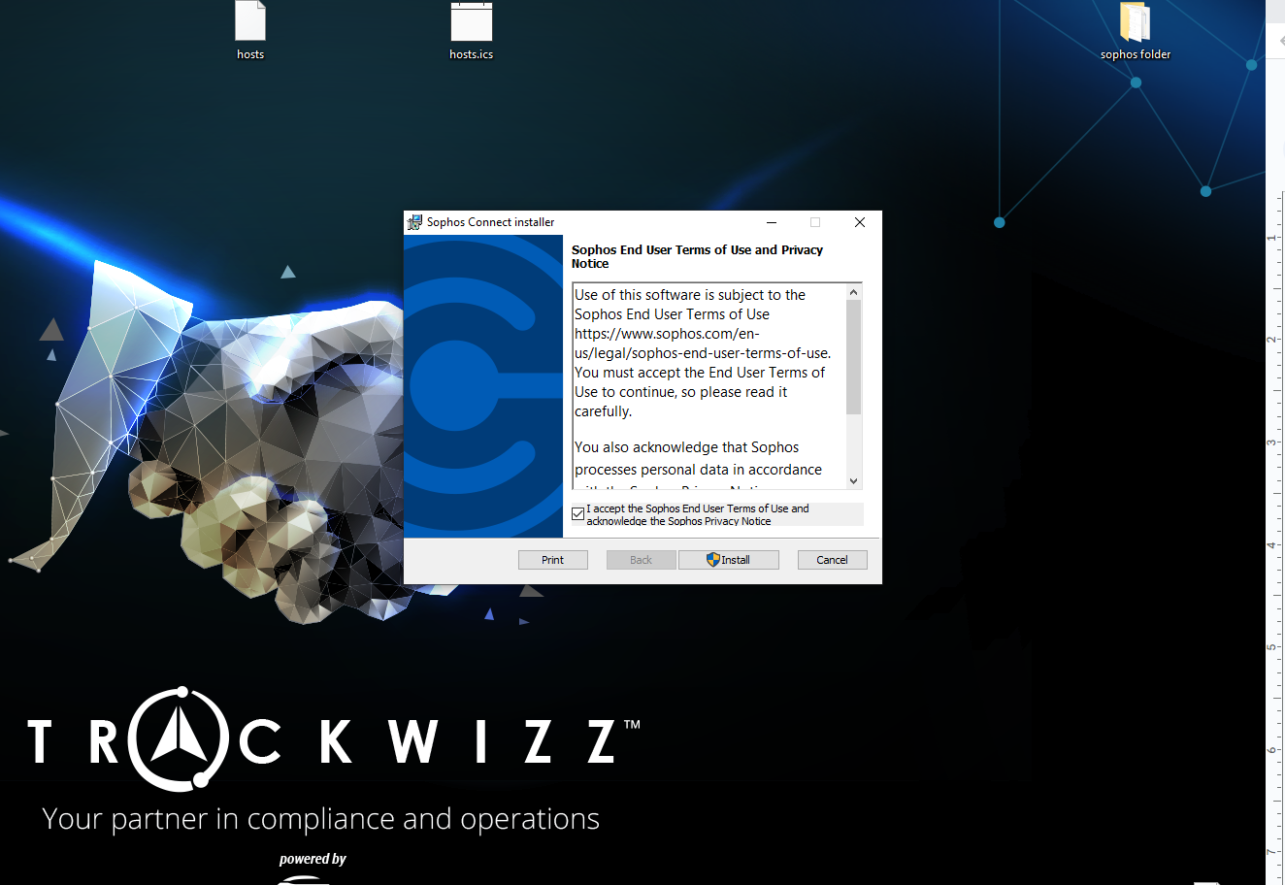

9. Right click on “Sophos Connect” and open it.

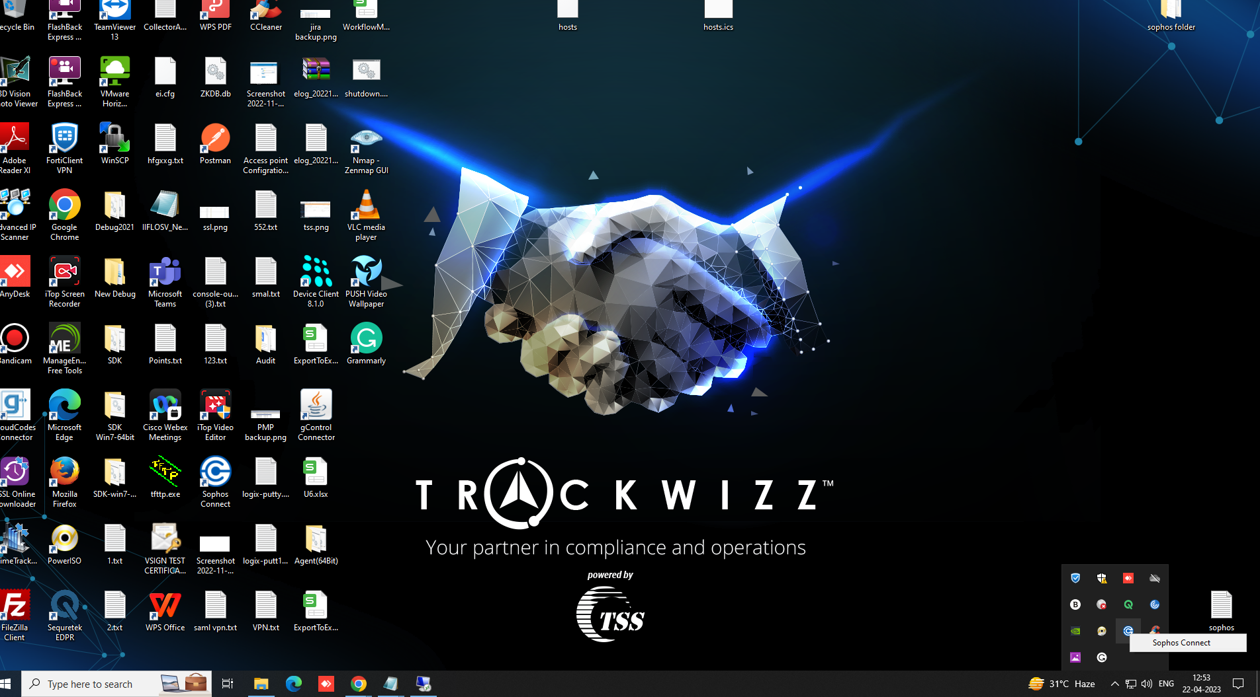

10. Click on the “Import Connection”and upload the SSL vpn configuration file in it.

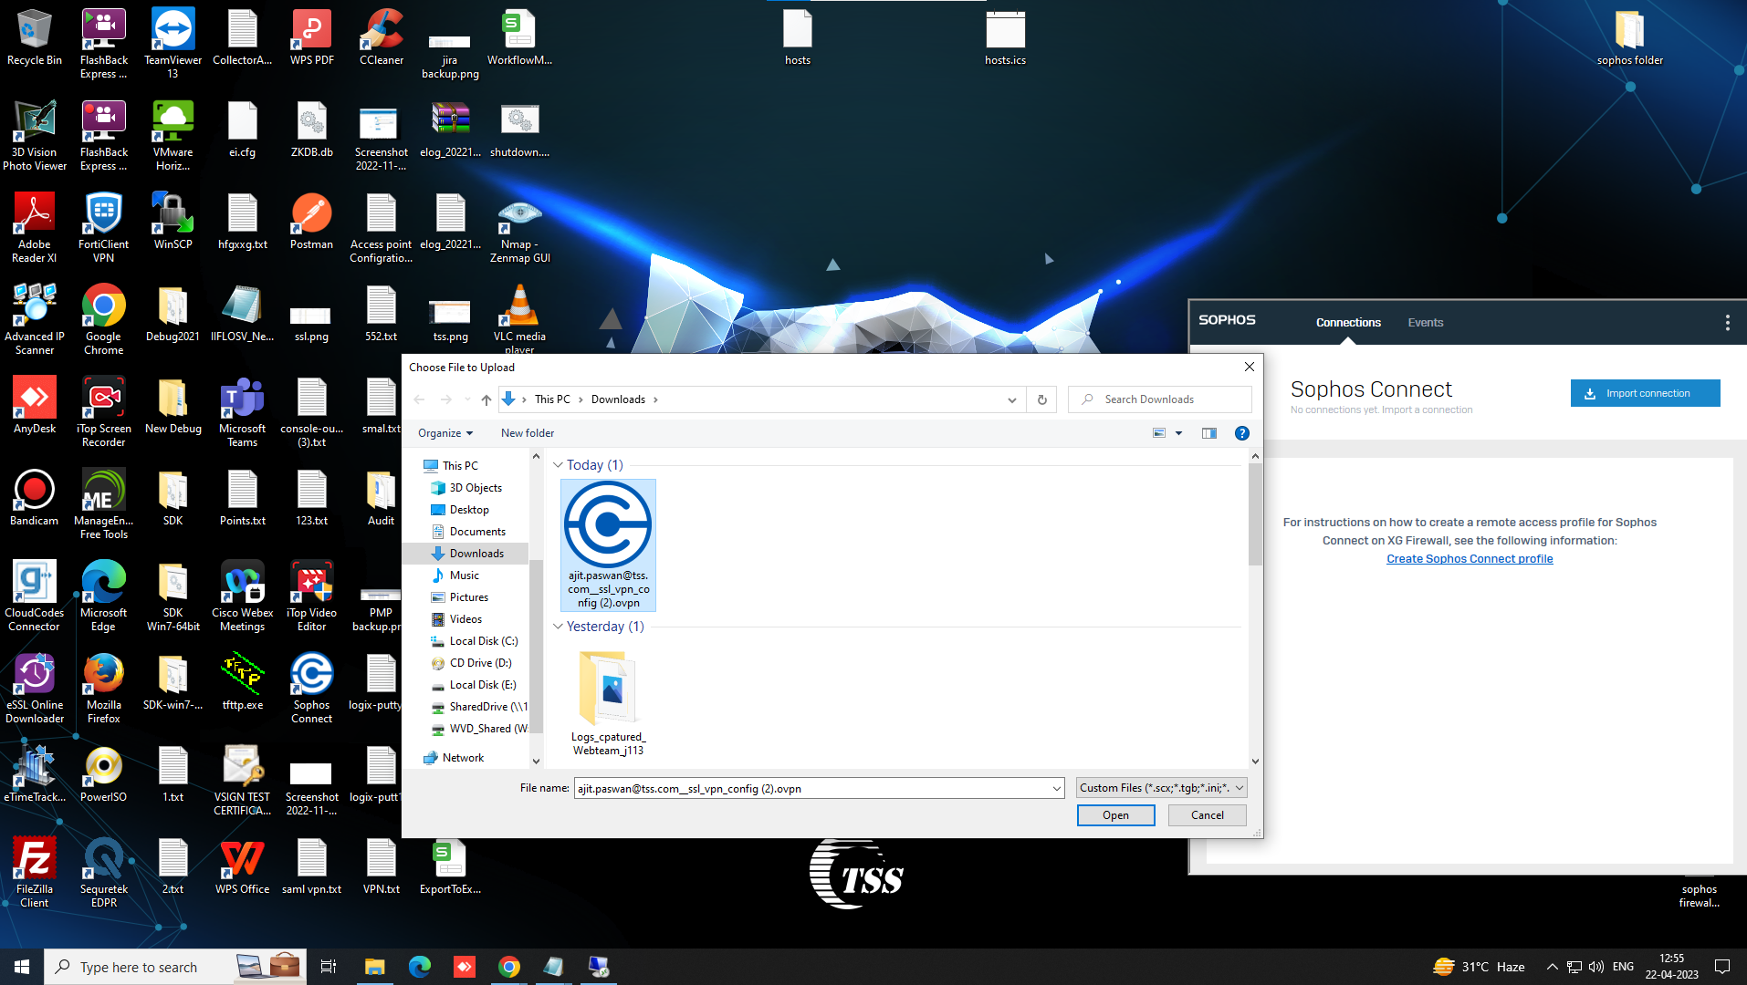

11.After this click on “Connect”tab and connect vpn with your windows credential.(Refers steps 6)

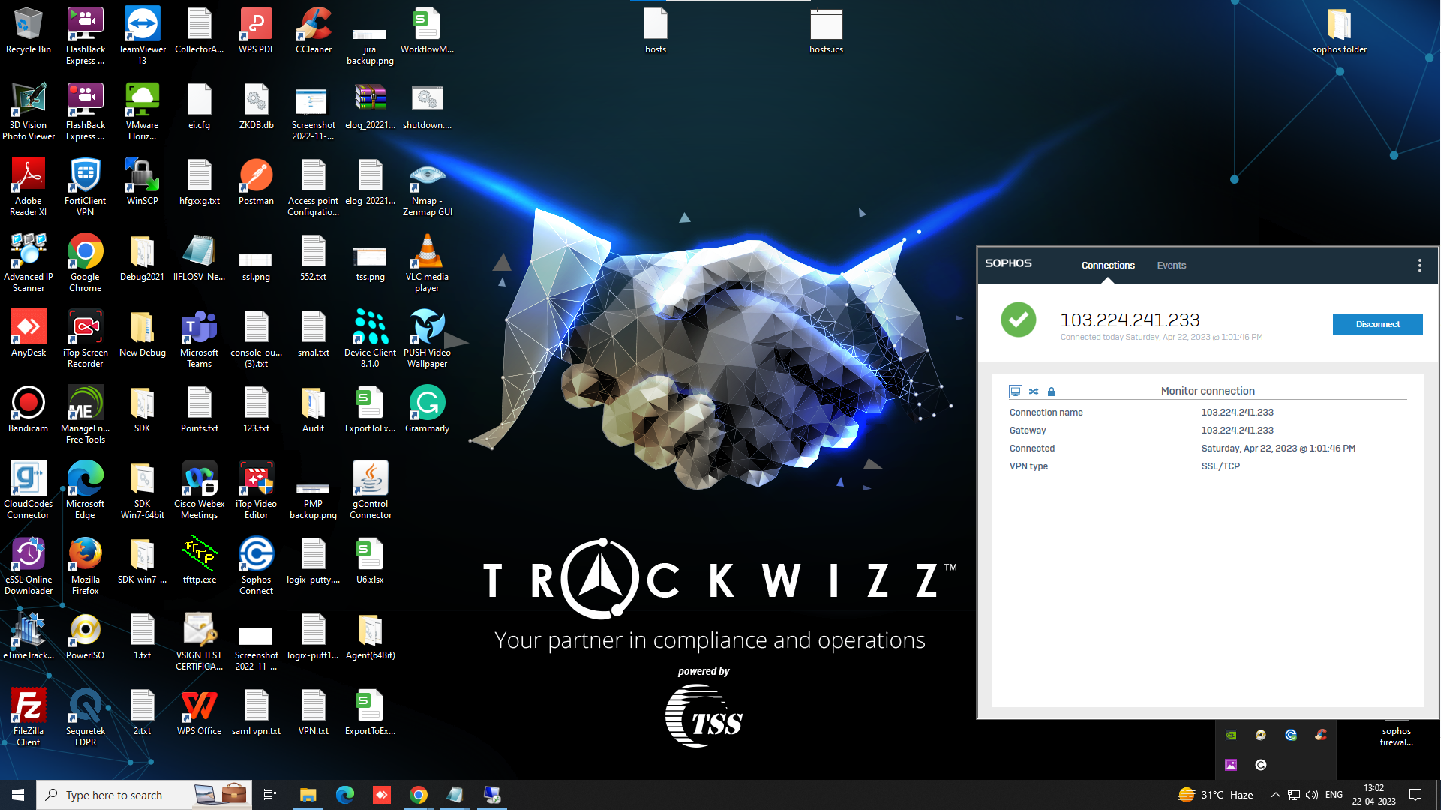

12.Now VPN connection established successfully.

13.After that VPN connection user’s will be able to connect Remote through RDP.

14.Connect your remote desktop with w.r.t your ip address for example.

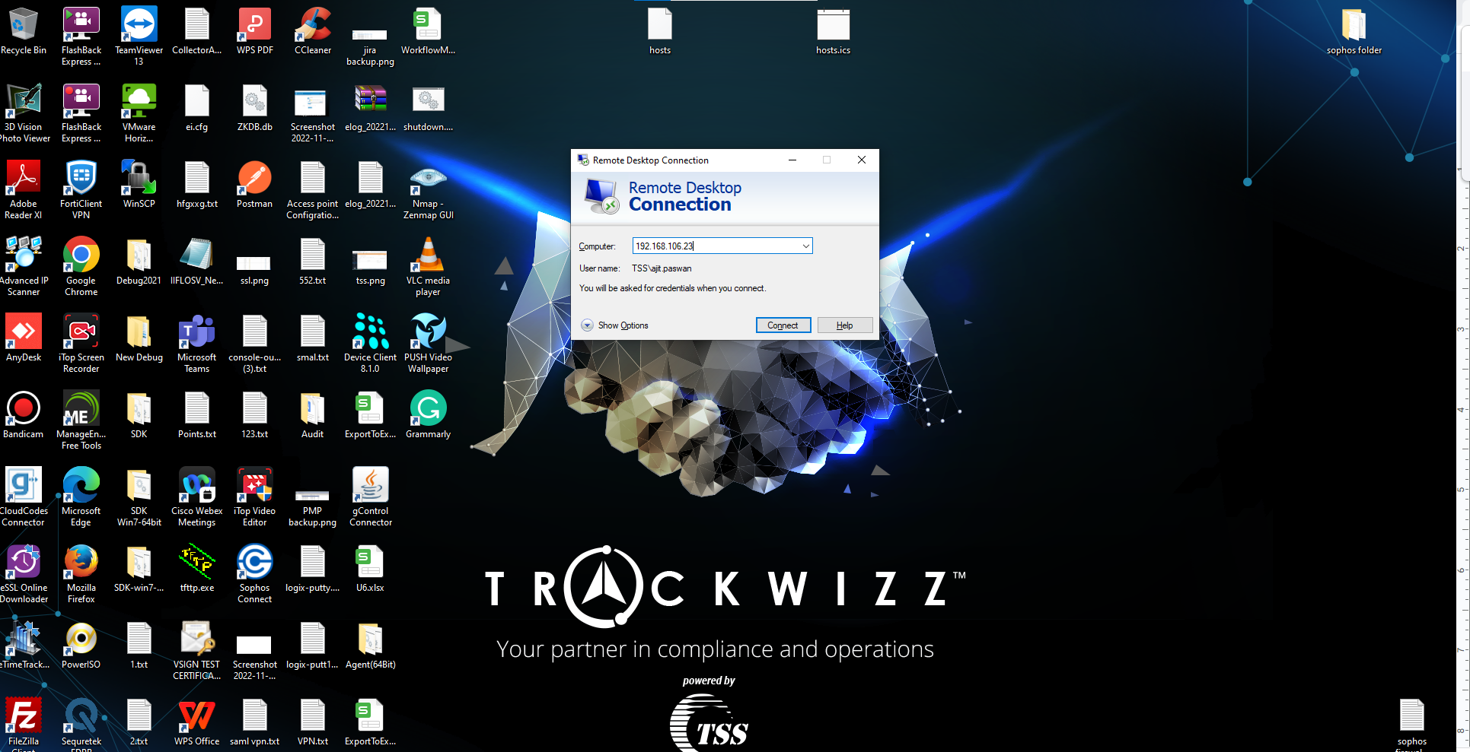

Thanks